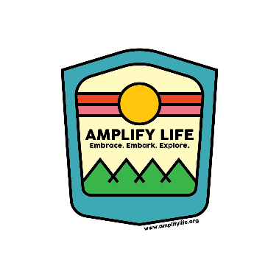

Volunteer Application
Please return application to Amplify Life: 480 Galletti Way, Bldg. 2, Sparks, NV 89431 Phone: (775) 827-3866 | Email: Luis@AmplifyLife.org

Personal Information:
First Name: __________________________________ Last Name: __________________________________________
Address: __________________________________________ City/State/Zip: ___________________________________
Primary Phone: _______________________________ Secondary Phone: ___________________________________
Email Address: ______________________________________________________________________________________
Have you ever been convicted of a Felony? □ Yes □ No
Are you 18 or older? □ Yes □ No If younger than 18, list age: ________________
Gender: □ Male □ Female
Complete if you are a student requiring civic service hours for class
School/University: ______________________________________________________
Class: _________________________________________________________________
Professor: ______________________________________________________________
Total number of hours required: _________________________________________ Date hours are due to be completed: ___________________________________ Briefly explain why you want to volunteer for Amplify Life.
____________________________________________________________________________________________________

____________________________________________________________________________________________________

____________________________________________________________________________________________________

Certifications:
□ CPR □ First Aide □ Other _________________________________________________

Emergency Contact Information:
Name: _______________________________________________ Relationship: _________________________________
Address: _____________________________________________ City/State/Zip: ________________________________ Primary Phone: _________________________________ Secondary Phone: _________________________________ Education:
High School: ______________________________________________________ Year Graduated: ________________
College: __________________________________________________________ Year Graduated: ________________

Current Employment:
Employer: ______________________________________________ Position Held: ______________________________
Supervisor Name: ______________________________________ Phone Number: _____________________________
Employer’s Address: ____________________________________ City/State/Zip: ______________________________
References(optional): Please list two non-family members that have knowledge of your character, experience, and abilities (Supervisors, co-workers, educators, family friends, etc.). At least one of these references must be a professional reference.
Name: _________________________________________________ Relationship: _______________________________
Primary Phone: __________________________________ Secondary Phone: ________________________________
Address: ________________________________________ City/State/Zip: _____________________________________
Name: _________________________________________________ Relationship: _______________________________
Primary Phone: __________________________________ Secondary Phone: ________________________________
Address: ________________________________________ City/State/Zip: _____________________________________

Volunteer Opportunities
The following schedule lists dates/programs currently available for you to volunteer. We require a limited number of volunteers at each program. Priority is given in the order applications are received.
When we receive your application, we will confirm by return email that you are approved to volunteer for selected dates. If the dates you selected are not available, we will ask you to select alternative date(s).
Once confirmed, put dates and times on your calendar with a reminder. One week prior to your volunteer experience with Amplify Life, you will receive a reminder email with program details. It is the ONLY reminder you will receive. If you are a no-show, we will remove you from our volunteer roster and we will not allow you to earn your hours with us.
What will I do as a volunteer?
Volunteers assist with programs. This includes set up and clean up, as well as, enthusiastically working with and supervising campers with scheduled activities. Programs may end slightly earlier than posted. In this event, you can leave and still earn your designated hours for that program.
What can I expect from the special needs individuals?
Most of our special needs campers are high functioning. They enjoy many of the same things you and I do. To program with us they must be independent in hygiene, ambulatory, able to follow direction, easily re-directed if necessary, and free from aggressive behavior. We have many campers who are non-verbal or challenging to understand, or visually impaired. We always have experienced staff on hand to assist if necessary. Expect a highly rewarding experience! Volunteer Caveat
Please note that when you volunteer for a program, you must work the entirety of that program. If you need only 1-hour of civic service to complete your commitment, but sign up for a program that is 4.5 hours in duration, you must work the entire duration of said program.
Amplify Life will sign off on hours at the end of your time volunteering with us.
Amplify Life will not advance you hours in exchange for your commitment to complete your hours after the due date. NO EXCEPTIONS TO THIS RULE. DO NOT ASK.
